**SUBMIT COIN FLOW**

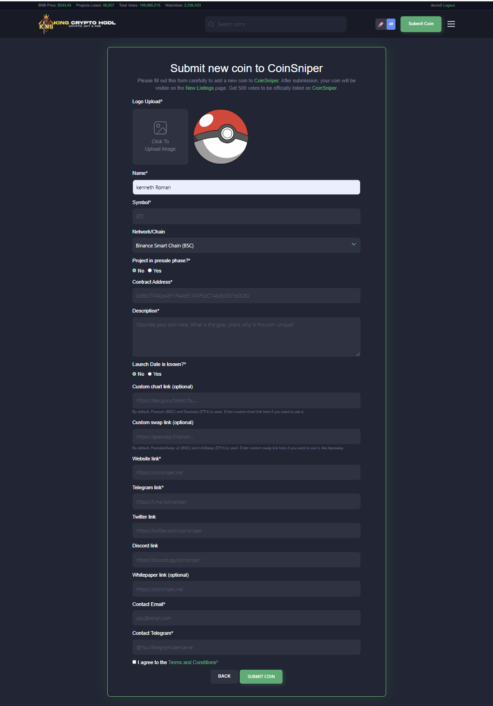

Picture : Fill up coin info